

AI STUDY COMPANION
A Mini Project Report submitted in partial fulfilment of the requirements for the award of the degree of

BACHELOR OF TECHNOLOGY
in

COMPUTER SCIENCE AND ENGINEERING (ARTIFICIAL INTELLIGENCE & MACHINE LEARNING)
Submitted by
Ch. Sri Priya 23R11A66B3
J. Srineeja 23R11A66C6
K. Ashish Reddy 23R11A66D0

Under the esteemed guidance of
Vedavyas Gurla
Associate Professor - CSE (AI&ML) Department


DEPARTMENT OF COMPUTER SCIENCE AND ENGINEERING (ARTIFICIAL INTELLIGENCE & MACHINE LEARNING)

Geethanjali College of Engineering and Technology Cheeryal(V), Keesara (M), Medchal(D), Telangana – 501301

September - 2026


CERTIFICATE

This is to certify that the Mini Project Report entitled AI STUDY COMPANION is a Bonafide work done and submitted by:
Ch. Sri Priya 23R11A66B3
J. Srineeja 23R11A66C6
K. Ashish Reddy 23R11A66D0

During the academic year 2026 - 2027, in partial fulfilment of requirement for the award of a Bachelor of Technology degree in CSE (Artificial Intelligence & Machine Learning) from Geethanjali College of Engineering and Technology (Accredited by NAAC with ‘A+’ Grade, Approved by AICTE and Affiliated to JNTUH), is a Bonafide record of work carried out by them under my guidance and supervision.
Certified further that to my best of knowledge, the work in this report has not been submitted to any other institution for the award of any degree or diploma.

Project Guide Project Co-Ordinator
(Vedavyas Gurla) (Mr. Shaik Akbar)

Head of the Department External Examiner
(Dr. L Venkateswarlu)

DECLARATION
The following is a declaration that the Mini Project report, "AI STUDY COMPANION" is an original work completed and submitted to the CSE (AI & ML) Department of Geethanjali College of Engineering & Technology, which is affiliated with Jawaharlal Nehru Technological University Hyderabad. It serves as a record of legitimate project work completed by me under the supervision of Vedavyas Gurla, Associate Professor, Department of CSE (AI & ML). We further affirm that none of the work included in this project has been applied for, in whole or in part, towards the award of any other degree or diploma.

Signature of the Student
Ch Sri Priya
23R11A66B3

Signature of the Student
J Srineeja
23R11A66C6

Signature of the Student
K Ashish Reddy
23R11A66D0

ACKNOWLEDGEMENT

We would like to extend our sincere gratitude to our distinguished Chairman, Sri. G. R. Ravinder Reddy, whose steadfast support has been indispensable to the successful completion of our Mini Project. We also express our heartfelt gratitude to our esteemed Vice Chairman, Sri. K. Harish Chandra Reddy, for his valuable support and encouragement throughout this journey. Our sincere appreciation goes to our respected Director, Dr. S. Udaya Kumar, GCET, whose guidance and insights have been instrumental in shaping our project. We are immensely grateful to our esteemed Principal, Dr. K. Sagar, GCET, for his unwavering support and direction during this entire process. Additionally, we extend gratitude to Dr. V. Madhusudan Rao, Professor and Dean, School of Computer Science and Informatics, for his continuous support and motivation.

We are immensely grateful to Dr. L. Venkateswarlu, Head of the Department, CSE (AI & ML), for his expertise, encouragement, and invaluable support, which have been instrumental in shaping our project's direction and outcomes. We extend our sincere appreciation to Mr. Shaik Akbar, Project Coordinator, CSE (AI & ML), for his steadfast support and guidance throughout this journey and also express heartfelt gratitude to our Project Guide, Vedavyas Gurla, Associate Professor, CSE (AI & ML), for his insightful suggestions, continuous support, and invaluable mentorship, which have greatly contributed to the successful completion of our project.

Lastly, we would like to express our heartfelt gratitude to our friends and family for their unwavering support, understanding, and encouragement throughout this endeavor. Their patience and belief have been a constant source of motivation, and we are immensely grateful for their presence in my life.

Ch Sri Priya 23R11A66B3
J Srineeja 23R11A66C6
K Ashish Reddy 23R11A66D0

ABSTRACT

AI STUDY COMPANION

The AI Study Companion is a web-based learning application designed to help students organize their study materials and learn more effectively using Artificial Intelligence. Instead of using AI tools only for asking questions, the system provides a complete study environment where students can manage subjects, upload study documents, generate learning resources, and track their progress.
Users can create separate workspaces for different subjects and upload PDF or DOCX files. The system extracts text from these documents using PyPDF2 and python-docx, stores the extracted content in a PostgreSQL database, and uses the Google Gemini API to generate personalized revision notes, exam preparation content, quizzes, and answers to study-related questions.
A unique feature of the project is its Interactive Concept Roadmap, which organizes concepts into a structured learning path. Students can study individual concepts, receive AI-generated explanations, attempt concept-specific quizzes, and mark concepts as mastered to unlock the next topics. The application also includes Logic Flow Visualization, which presents step-by-step explanations for processes, making complex topics easier to understand.
The system maintains chat history and generated content history for each workspace, allowing students to continue learning without losing previous work. With a modern React frontend, FastAPI backend, PostgreSQL database, and Gemini AI integration, the project provides a personalized, organized, and interactive learning experience that goes beyond traditional AI chat applications.
Tools Required for Implementation:
1. Frontend Development Tools
- React.js: Builds the user interface using reusable components.
- Vite: Provides fast development server and project build.
- JavaScript (ES6+): Implements frontend logic and interactions.
- HTML5: Creates the webpage structure.
- CSS3: Designs the user interface, animations, and responsive layout.
- Lucide React: Provides modern icons used throughout the application.
2. Backend Development Tools
- Python: Main programming language for backend development.
- FastAPI: Builds REST APIs and handles backend requests.
- SQLAlchemy: Performs Object Relational Mapping (ORM) for database operations.
- PostgreSQL: Stores users, workspaces, documents, chat history, and generated content.
- Pydantic: Validates API request and response data.
- Passlib: Hashes and verifies user passwords securely.
- Haversine: Runs the FastAPI application server.

- JWT: Provides secure user authentication.

3. Data Processing Tools
- PyPDF2: Extracts text from uploaded PDF documents.
- python-docx: Used as an alternative source for air-quality and pollutant data.
- Google Gemini API: Generates revision notes, exam preparation content, quizzes, roadmap content, logic flow explanations, and chat responses based on extracted text.
- JSON: Stores structured AI-generated roadmap and metadata information.

TABLE OF CONTENTS
- Abstract ii
- Table of Contents iv
- List of Figures vii
  - INTRODUCTION 1
- About the Project……………………………………………………………………………………
- Problem Statement………………………………………………………………………………….
- Project Objectives…………………………………………………………………………………..
  - LITERATURE SURVEY 3
- Existing Work………………………………………………………………………………………
- Limitations………………………………………………………………………………….............
- Our Innovation and Improvements………………………………………………………………….
- Technology Stack…………………………………………………………………………………...
  - SOFTWARE REQUIREMENTS ANALYSIS 5
    - Modules and their Functionalities ………………………………………………………...............
      - Video Capture Module………………………………………………………………………..
      - Preprocessing Module………………………………………………………………………...
      - Emotion Detection Module…………………………………………………………………...
      - Violence Risk Detection Module……………………………………………………………...
      - Multimodal Fusion Module…………………………………………………………………...
      - Alert and Reporting Module…………………………………………………………………..
      - Dashboard Module……………………………………………………………………………

HARDWARE REQUIREMENTS ANALYSIS 6
    - Hardware Requirements……………………………………………………………………………
    - Additional Requirements…………………………………………………………………………..

SYSTEM ARCHITECTURE DIAGRAM 7
  - METHODOLOGIES AND IMPLEMENTATION 8
    - Methods……………………………………………………………………………………………...
    - Models……………………………………………………………………………………………….
    - Model Implementation Workflow…………………………………………………………………..
    - Internal Implementation Workflow…………………………………………………………………
    - Fusion Models……………………………………………………………………………………….

    - Interface & Integration………………………………………………………………………………

MODEL IMPLEMENTATION 12
    - Imports and Dependencies……………………………………………………………………………...
    - Configuration and Path Setup….……………………………………………………………………….
    - Data Scanning and Loading Functions…………………………………………………………………
      - CREMA-D Function………………………………………………………………………….
      - RAF_DB……………………………………………………………………………………...
      - Extracting Audio Features……………………………………………………………………
      - Preprocessing Image………………………………………………………………………….
      - Dataset Scanning and Splitting……………………………………………………………….
    - Data Generators………………………………………………………………………………………...
      - MultiModal Class Generator………………………………………………………………….
      - Initialization…………………………………………………………………………………..
      - Batch Count & Fetching……………………………………………………………………...
      - Batch Data Generation………………………………………………………………………..
      - Generator Instances…………………………………………………………………………...
    - Model Definition Functions…………………………………………………………………………….
      - Audio Processing Neural Network…………………………………………………………...
      - Face Analysis Neural Network……………………………………………………………….
    - Model Training Execution……………………………………………………………………………...
      - Audio Model Training………………………………………………………………………..
      - Face Model Training………………………………………………………………………….
    - Unimodal Accuracy Reporting…………………………………………………………………………
      - Calculating Accuracy…………………………………………………………………………
      - Model Evaluations……………………………………………………………………………
  - Fusion Data Preparation………………………………………………………………………………..
    - Motion Data Scanning………………………………………………………………………..
    - Minimum Length Alignment…………………………………………………………………
    - Data Truncation……………………………………………………………………………...
    - Simulated Motion Scores…………………………………………………………………….
    - Fusion Data Assembly…………………………………………………………….................
  - Fusion Logic and Prediction Pipeline………………………………………………………………….
    - Motion Agitation Score………………………………………………………………………
    - Live Preprocessing Functions………………………………………………………………..
    - Rule-Based Fusion Logic…………………………………………………………………….

    - Main Prediction Function……………………………………………………………………
  - Gradio Interface Deployment………………………………………………………………………...
7.10.1. Gradio Interface Definition…………………………………………………………………
7.10.2 Launch Interface…………………………………………………………………………….

PIPELINE SUMMARY 36

MODEL OUTPUT 37
    - Result of Monitoring System ……………………………………………………………………………..
    - Result of Pollution Monitoring……………………………………………………………………………….

CONCLUSIONS 39

FUTURE ENHANCEMENTS 40

REFERENCES 41

LIST OF FIGURES

Description | Page No.
System Architecture Diagram | 16
Sample Model Implementation Workflow | 19
Project Sequence Diagram | 46
Result of Monitoring System | 48
Result of pollution monitoring | 49

LIST OF ABBREVIATIONS

AI Artificial Intelligence
AQI Air Quality Index
API Application Programming Interface
ERS Environmental Risk Score
ML Machine Learning
MAE Mean Absolute Error
RMSE Root Mean Square Error
MAPE Mean Absolute Percentage Error
PM2.5 Particulate Matter 2.5
PM10 Particulate Matter 10

INTRODUCTION

ABOUT THE PROJECT

The AI-Powered Study Companion is a web-based learning application that helps students organize their study materials and learn more effectively using Artificial Intelligence. Instead of using AI tools only for asking questions, the application provides a complete study environment where students can upload study documents, generate learning resources, and track their progress.
Students can create separate workspaces for different subjects and upload PDF or DOCX files. The system extracts text from these documents, stores it in a PostgreSQL database, and uses the Google Gemini API to generate revision notes, exam preparation content, quizzes, logic flow explanations, and AI-powered chat responses based on the uploaded material.
The project also includes an Interactive Concept Roadmap, allowing students to learn concepts step-by-step, receive concept-specific AI explanations, attempt quizzes, and mark concepts as mastered. By combining document management, AI assistance, and progress tracking in one platform, the system provides a more organized and personalized learning experience.

PROBLEM STATEMENT

Students today use AI tools like ChatGPT and Google Gemini to understand concepts, create notes, and prepare for exams. However, these tools are general-purpose AI assistants and do not provide a structured environment for managing academic study materials. Students often have to repeatedly upload documents, switch between different applications, and manually organize their study resources, which makes the learning process less efficient.
The major problems identified are:
      - Lack of subject-wise organization: Students cannot easily organize different subjects into separate study spaces.
      - Poor document management: Managing multiple PDF and DOCX files for a single subject becomes difficult.
      - No personalized learning workflow: Existing tools provide answers but do not offer revision notes, exam preparation, quizzes, and concept-based learning in one platform.
      - Limited progress tracking: Students cannot easily track what they have already studied or mastered.
      - Scattered learning experience: Chat history, generated content, and study materials are often spread across multiple sessions and applications.

Our solution: The AI-Powered Study Companion addresses these challenges by providing workspace-based study management, AI-powered chat based on uploaded documents, automatic revision and exam content generation, quizzes, concept roadmaps, and learning progress tracking within a single platform.

PROJECT OBJECTIVES
Primary objectives:

- To develop an AI-powered study platform for students.
- To organize study materials using subject-specific workspaces.
- To extract text from uploaded PDF and DOCX documents.
- To generate revision notes, exam preparation content, and quizzes using AI.
- To provide context-aware AI chat based on uploaded study materials.
- To improve learning through interactive concept roadmaps and logic flow visualization.

Secondary objectives:

- To maintain chat history for each workspace.
- To store previously generated study content for future access.
- To allow students to manage multiple documents within a workspace.
- To provide concept-specific AI explanations and quizzes.
- To track learning progress through concept mastery.
- To create a modern, user-friendly interface with dark and light mode support.
- To build a scalable system using React, FastAPI, PostgreSQL, and the Google Gemini API.

LITERATURE SURVEY

EXISTING WORK

Several AI-powered learning platforms and educational applications are currently available. They help students understand concepts, generate notes, and answer questions, but they have certain limitations.

- ChatGPT: Provides AI-based explanations, summaries, coding assistance, and answers to academic questions.
- Google Gemini: Supports document understanding and AI-powered question answering using uploaded files.
- Notion AI: Helps users create notes, summarize documents, and improve writing productivity.
- Learning Management Systems (Moodle, Coursera, Khan Academy): Offer structured courses, assignments, and learning resources for students.
- Document Summarization Tools: Generate summaries from uploaded documents but usually focus on only one task at a time.

LIMITATIONS OF EXISTING WORK

The study of existing systems revealed several limitations:
No subject-wise workspace management for organizing different courses separately.
Limited support for managing multiple study documents within one subject.
Repeated document uploads are often required in new sessions.
No integrated learning workflow combining revision, exam preparation, quizzes, and AI chat.
Lack of concept-based learning roadmaps generated from uploaded materials.
Limited progress tracking, making it difficult for students to continue learning from previous sessions.
Scattered study resources, as notes, chats, and generated content are not centrally organized.

OUR INNOVATION AND IMPROVEMENTS

Existing Systems | Our Project Improvements
General AI chat | AI chat based on uploaded study materials
Temporary document interaction | Permanent subject-wise workspaces
Single-document focus | Multiple PDF/DOCX support in one workspace
Basic summaries | Revision notes, exam preparation, quizzes, and logic flow
No concept roadmap | Interactive AI-generated concept roadmap
No mastery tracking | Concept mastery and progress tracking
Separate learning tools | All study features integrated into one platform
Limited history | Chat history and generated content history for each workspace

TECHNOLOGY STACK

 | Technology Used
  Category | Technology Used
Frontend | React.js, Vite, JavaScript, HTML5, CSS3
Icons | Lucide React
Backend | FastAPI, Python 3.11
Database | PostgreSQL
ORM | SQLAlchemy
Authentication | JWT, Passlib
Validation | Pydantic
Server | Uvicorn
PDF Processing | PyPDF2
DOCX Processing | python-docx
AI Integration | Google Gemini API
Data Format | JSON

SOFTWARE REQUIREMENT ANALYSIS

Modules and Their Functionalities

3.1.1 User Authentication Module
- Allows users to register and log in securely.
- Uses JWT authentication to maintain user sessions.
- Protects user data by storing encrypted passwords.
3.1.2 Workspace Management Module
- Allows users to create separate workspaces for different subjects.
- Helps organize study materials subject-wise.
- Supports selecting and deleting workspaces.
3.1.3 Document Management Module
- Enables users to upload PDF and DOCX files.
- Allows viewing and deleting documents within a workspace.
- Manages multiple documents under the same subject.
3.1.4 Text Extraction Module
- Extracts text from PDF files using PyPDF2.
- Extracts text from DOCX files using python-docx.
- Stores the extracted text for AI processing.
3.1.5 AI Chat Module
- Allows students to ask questions based on uploaded study materials.
- Generates context-aware responses using the Gemini API.
- Maintains chat history for each workspace.
3.1.6 Concept Roadmap Module
• Generates an AI-powered concept roadmap from study materials.
• Organizes concepts into a step-by-step learning path.
• Unlocks new concepts as previous ones are mastered.

HARDWARE REQUIREMENT ANALYSIS

Hardware Requirements

Component | Specification / Requirement
Processor | Intel Core i3 or above
RAM | 8 GB RAM (minimum 4 GB)
Storage | Minimum 2 GB Free Disk Space
Display | 1366 × 768 Resolution or higher
Internet Connection | Stable broadband/Wi-Fi connection
Keyboard and Mouse | Standard keyboard and Mouse
Operating System | Windows 10/11

SYSTEM ARCHITECTURE DIAGRAM

Explanation:
- User (Student): Interacts with the application through a web browser to access all study features.
- React Frontend: Provides the user interface for workspaces, chat, quizzes, roadmaps, and document management.
- FastAPI Backend: Processes user requests, manages business logic, and connects the frontend with the database and AI services.
- Document Processing: Uses PyPDF2 and python-docx to extract text from uploaded PDF and DOCX files.
- PostgreSQL Database: Stores users, workspaces, documents, extracted text, chat history, generated content, and learning progress.
- Google Gemini API: Generates AI-powered chat responses, revision notes, exam preparation content, quizzes, concept roadmaps, and logic flow explanations.
- Generated Learning Resources: Displays personalized study materials such as AI chat, revision notes, exam content, quizzes, roadmaps, and logic flow for the student.

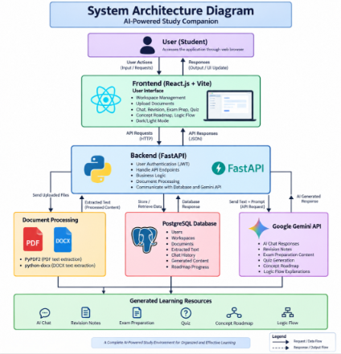

Fig. 5.1 System Architecture Diagram

METHODOLOGIES & IMPLEMENTATION

Methods

The system follows a workspace-based learning approach, where each subject is organized into a separate workspace.

It uses AI-assisted content generation to create revision notes, exam preparation material, quizzes, and chat responses from uploaded documents.

The application combines document management with personalized learning features such as roadmaps and progress tracking.

Models

Google Gemini 2.5 Flash is used as the primary AI model for generating study content and answering questions.

JWT Authentication is used to securely manage user login sessions.

SQLAlchemy ORM is used to connect Python objects with the PostgreSQL database.

Model Implementation Workflow

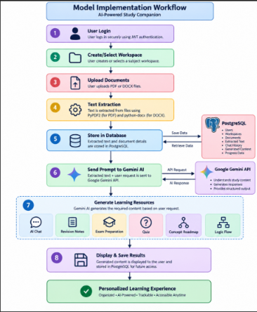

STEP-1:

User Login: The student logs in securely using JWT authentication.

STEP-2:

Create Workspace: A separate workspace is created for each subject.

STEP-3:

Upload Document: PDF or DOCX files are uploaded into the selected workspace.

STEP-4:

Text Extraction: The system extracts text from the uploaded document.

STEP-5:

Database Storage: Extracted content is stored in PostgreSQL.

STEP-6:

AI Processing: The user's request and extracted text are sent to Gemini AI.

STEP-7:

Content Generation: AI generates revision notes, quizzes, exam content, roadmap, or chat responses.

STEP-8:

Result Storage: The generated content and chat history are saved for future access.

Internal Implementation Workflow
- The frontend sends API requests to the FastAPI backend whenever the user performs an action.
- The backend processes the request, retrieves the required data from PostgreSQL, and communicates with Gemini AI when needed.
- The generated response is returned to the frontend and stored in the database for future use.

Fusion Models
      - React + FastAPI + PostgreSQL work together to provide a complete full-stack application.
      - PyPDF2 + python-docx + Gemini AI combine document processing with AI-powered learning.
      - Concept Roadmap + AI Chat provide both structured learning and interactive doubt clarification.

Interface & Integration
- The application provides a modern interface with dark and light mode support for a better user experience.
- A tab-based workspace allows users to switch easily between documents, chat, quizzes, and generated content.
- The dashboard organizes all learning resources within subject-specific workspaces.
- The frontend communicates with the backend through REST APIs built using FastAPI.
- PostgreSQL stores user data, uploaded documents, chat history, generated content, and roadmap progress.
- The Google Gemini API integrates with the backend to generate AI-powered learning resources based on uploaded documents.

MODEL IMPLEMENTATION

Project Dependencies

Backend Dependencies

Dependency | Purpose
FastAPI | Builds the backend REST APIs.
Uvicorn | Runs the FastAPI application server.
SQLAlchemy | Connects Python code with PostgreSQL.
Pydantic | Validates API request and response data.
psycopg2-binary | Connects FastAPI with PostgreSQL.
python-jose | Generates and verifies JWT authentication tokens.
Passlib | Hashes and verifies user passwords securely.
bcrypt | Encrypts passwords before storing them.
python-multipart | Handles file uploads from the frontend.
google-generativeai | Integrates the Google Gemini AI model.
PyPDF2 | Extracts text from PDF documents.
python-docx | Extracts text from DOCX documents.
python-dotenv | Loads environment variables from the .env file.

Frontend Dependencies

Dependency | Purpose
React | Builds the user interface.
Vite | Provides fast development and project building.
Lucide React | Adds modern icons to the interface.
React Markdown | Displays AI-generated Markdown content properly.

Database Dependency

Dependency | Purpose
PostgreSQL | Stores users, workspaces, documents, chats, and generated content.

AI Dependency

Dependency | Purpose
Google Gemini 2.5 Flash | Generates AI-powered study content and chat responses.

  - User Authentication
The application uses JWT (JSON Web Token) authentication to provide secure user login and maintain user sessions.

Sample Implementation
access_token = create_access_token(
data={"sub": str(user.id)}
)

Why it is used
- Provides secure authentication without storing passwords in plain text.
- Allows users to access only their own workspaces and data.
How it works
- After successful login, the backend generates a JWT token.
- The frontend stores the token and sends it with every protected API request.

Document Upload
Users can upload PDF and DOCX files into subject-specific workspaces.
Sample implementation
const formData = new FormData();
formData.append("file", file);
Why it is used
- Supports uploading different study materials.
- Keeps documents organized inside individual workspaces.
How it works
- The frontend sends the selected file to the backend.
- The backend stores the file and prepares it for text extraction.

Text Extraction
The backend extracts text from uploaded documents before AI processing.
Sample implementation
text += page.extract_text() or ""
Why it is used
- Converts document content into readable text.
- Makes the content available for AI-generated responses.
How it works
- PyPDF2 extracts text from PDF files.
- python-docx extracts paragraphs from DOCX files.

Database Storage
The extracted text and workspace information are stored in PostgreSQL.
Sample implementation
db.add(document)
db.commit()
Why it is used
- Stores user data permanently.
- Avoids extracting the same document repeatedly.
How it works
- SQLAlchemy maps Python objects to database tables.
- The backend retrieves stored content whenever needed.

AI Content Generation
The project uses Google Gemini 2.5 Flash to generate personalized learning resources.
Sample implementation
response = model.generate_content(prompt)
Why it is used
- Generates revision notes, exam preparation content, quizzes, and chat responses.
- Produces content based on uploaded study material.
How it works
- The backend combines extracted text with the user's request.
- Gemini returns context-aware responses instead of general answers.

Context-Aware Chat
The chat feature answers questions using the uploaded documents of the selected workspace.
Sample implementation
prompt = f"{document_text}\n\nQuestion: {message}"
Why it is used
- Keeps conversations relevant to the student's study material.
- Reduces the need to repeatedly upload documents.
How it works
- The backend retrieves the stored document text.
- The user's question is added to the prompt before sending it to Gemini.

Concept Roadmap Generation
The application generates an interactive roadmap from uploaded documents.
Sample implementation
roadmap = generate_concept_graph(text)
Why it is used
- Organizes concepts into a logical learning path.
- Helps students study topics step by step.
How it works
- Gemini analyzes the extracted text.
- The backend stores the roadmap as structured JSON for frontend visualization.

Content History
The application stores previously generated AI content for future access.
Sample implementation
db.add(generated_content)
db.commit()
Why it is used
- Prevents users from losing previous AI-generated content.
- Allows quick access without regenerating content.
How it works
- Every generated response is stored in the database.
- Users can view or delete previous content from the Content History section.

PIPELINE SUMMARY

The AI-Powered Study Companion follows a structured workflow where user-uploaded study materials are processed and converted into personalized learning resources using Artificial Intelligence.
Pipeline Steps
- User Authentication: The student logs in and accesses their personal study workspace.
- Workspace Management: A separate workspace is created or selected for each subject.
- Document Upload: PDF or DOCX study materials are uploaded into the workspace.
- Text Extraction: The backend extracts text using PyPDF2 and python-docx.
- Data Storage: Extracted text and user information are stored in PostgreSQL.
- AI Processing: The backend sends the extracted text and user request to Google Gemini.
- Content Generation: Gemini generates AI chat responses, revision notes, exam preparation content, quizzes, roadmaps, and logic flow explanations.
- Result Storage: The generated content and chat history are saved for future access.
- User Learning: Students continue learning through AI chat, quizzes, roadmaps, and previous content history.

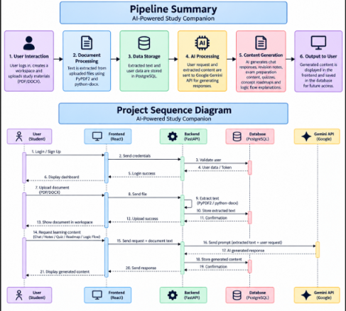
Fig. 8.1Poipeline Summary & Project Sequence Diagram

The sequence diagram illustrates how different components communicate while processing a user request.
Sequence Flow
- The User sends a request through the React frontend.
- The Frontend forwards the request to the FastAPI backend.
- The Backend validates the user and retrieves workspace information from PostgreSQL.
- For document uploads, the backend extracts text and stores it in the database.
- For AI features, the backend combines the extracted text with the user's request.
- The request is sent to the Google Gemini API.
- Gemini returns the AI-generated response.
- The backend stores the generated content in PostgreSQL.
- The frontend displays the final response to the user.

MODEL OUTPUTS

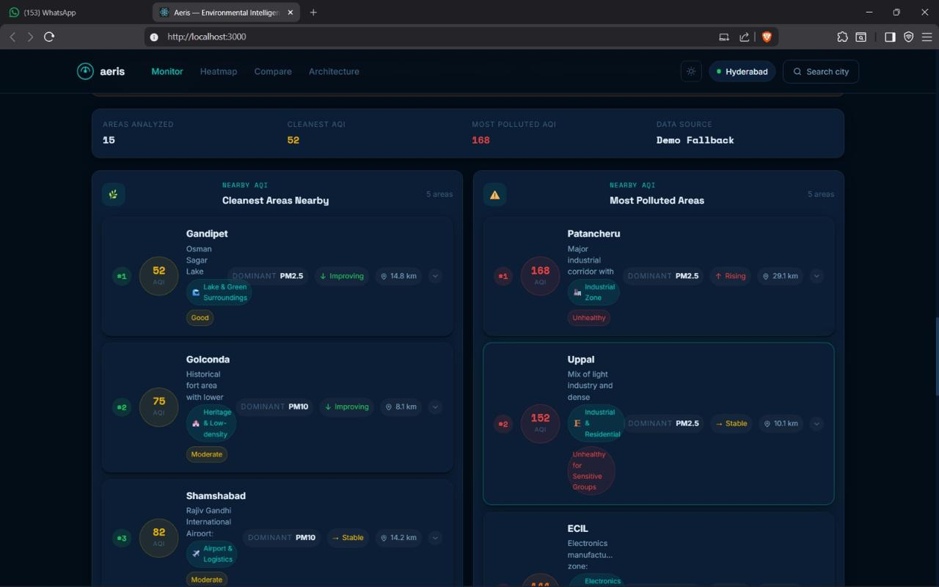
Fig. 9.1 Monitoring System

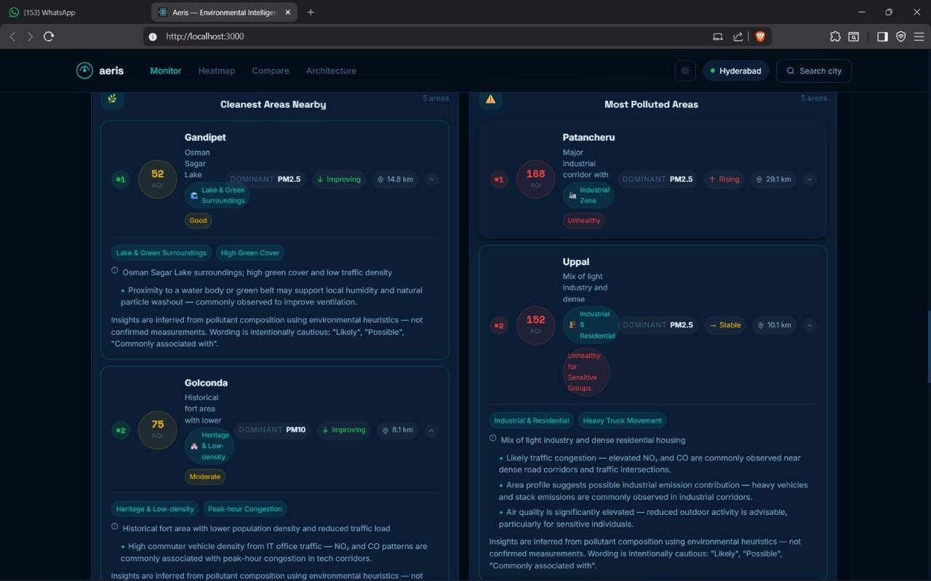
Fig. 9.2 Result of Mosted polluted A

CONCLUSION

The AI-Powered Study Companion successfully provides a smart and organized learning platform that helps students manage their study materials and learn more effectively using Artificial Intelligence. The project combines document management, AI-powered content generation, and progress tracking within a single application, making the learning process more structured and personalized.
By allowing students to upload PDF and DOCX files into subject-specific workspaces, the system generates revision notes, exam preparation content, quizzes, concept roadmaps, logic flow explanations, and context-aware chat responses based on the uploaded study material. The application also maintains chat history, generated content history, and learning progress, enabling students to continue their studies without losing previous work.
The project demonstrates how modern web technologies such as React, FastAPI, PostgreSQL, and the Google Gemini API can be integrated to build a practical AI-assisted educational platform.

Key Goals Achieved Through This Project
- Developed a secure workspace-based learning platform with user authentication.
- Implemented PDF and DOCX document upload with automatic text extraction.
- Integrated Google Gemini AI for personalized study assistance.
- Generated revision notes, exam preparation content, quizzes, and logic flow explanations.
- Enabled context-aware AI chat based on uploaded study materials.
- Created an interactive concept roadmap with mastery-based learning progression.
- Maintained chat history and generated content history for each workspace.
- Built a modern, responsive interface with dark/light mode and tab-based navigation.
- Successfully integrated the frontend, backend, database, and AI services into a complete full-stack application.

FUTURE ENHANCEMENTS

The AI-Powered Study Companion can be further improved by adding the following features:
- Voice-Based AI Chat: Allow students to ask questions and receive answers using voice input and output.
- OCR Support for Scanned PDFs: Extract text from image-based or handwritten documents using Optical Character Recognition.
- Mobile Application: Develop Android and iOS versions for learning on the go.
- Study Reminders: Send notifications for revision schedules, quizzes, and upcoming study goals.
- Collaborative Workspaces: Enable students to share workspaces and study together in groups.
- Multi-Language Support: Generate study content and chat responses in multiple languages.
- Advanced Learning Analytics: Provide detailed reports on quiz performance, study time, and concept mastery.
- Cloud Storage Integration: Connect with Google Drive, OneDrive, or Dropbox for direct document import.
- Offline Study Mode: Allow students to access previously generated content without an internet connection.
- Personalized AI Recommendations: Suggest the next topic to study based on the student's learning progress and mastered concepts.
These enhancements would make the system more interactive, accessible, and suitable for a wider range of learning needs while building upon the existing features of the project.

12. REFERENCES

- Google AI, Gemini API Documentation. Available: https://ai.google.dev/
- FastAPI, FastAPI Official Documentation. Available: https://fastapi.tiangolo.com/
- PostgreSQL Global Development Group, PostgreSQL Documentation. Available: https://www.postgresql.org/docs/
- React Team, React Official Documentation. Available: https://react.dev/

